EXPERIMENT NO. 6

AIM :- To Study the structural and implementation process of lex and YACC tools and prepare a detail analysis report.

ALGORITHM:-

1.write lex program in a file file.l and yacc in a file.y

2.open the terminal and navigate to the directory where you have save the files.

3. type lex file.l

4. type yacc –d file.y

5. type cc lex.yy.c y.tab.h –ll

6. type ./a.out

CODE:-

LEX PROGRAM:-

%{  
#include"y.tab.h"  
#include<math.h>  
extern yylval;  
%}  
%%  
[0-9]+ {yylval=atoi(yytext);return NUM;}  
[+] {return '+';}  
[-] {return '-';}  
[\*] {return '\*';}  
[/] {return '/';}  
[\t]+;  
[\n] {return 0;}  
.{return yytext[0];  
}  
%%

YACC PROGRAM:-  
  
%{

#include<stdio.h>  
%}  
%token NUM  
%left '-''+'  
%right '\*''/'  
%%  
start: exp {printf("%d\n",$$);}  
exp:exp'+'exp {$$=$1+$3;}  
|exp'-'exp {$$=$1-$3;}  
|exp'\*'exp {$$=$1\*$3;}  
|exp'/'exp  
{  
if($3==0)  
yyerror("error");  
else  
{  
$$=$1/$3;  
}  
}  
|'('exp')' {$$=$2;}  
|NUM {$$=$1;}  
;  
%%  
main()  
{  
printf("Enter the Expr. in terms of integers\n");  
if(yyparse()==0)  
printf("Success\n");  
}  
yywrap(){}  
yyerror()  
{  
printf("Error\n");  
}

OUTPUT:-

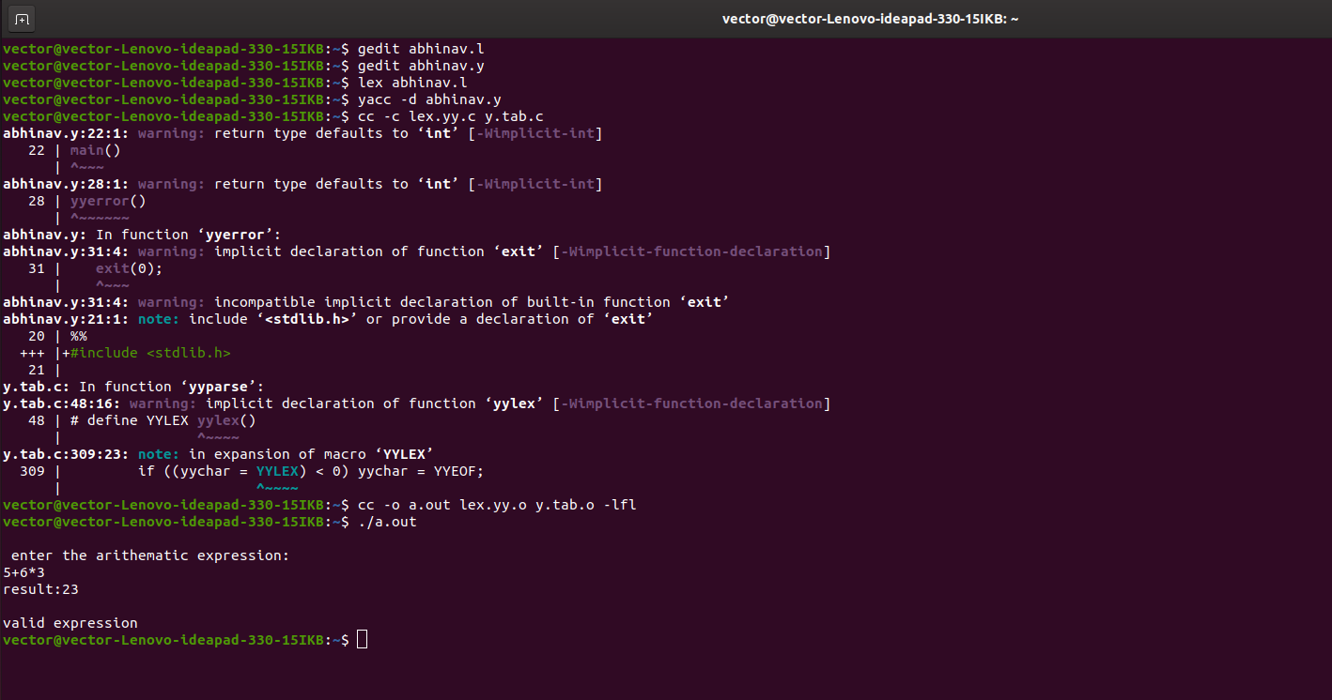

RESULT:-

Thus we had Studied the structural and implementation process of lex and YACC tools and also prepared a detail analysis report by implementing calculator using lex and yacc.